CTAM Internal Testing Feature

Motivation:

- Encourage users to adopt CTAM for not just compliance testing but also for internal validation.
- Permits IP sensitive test content to be accidentally pushed to Github.
- Permits test content to be well defined and validated before exposure to external users.

Goals:
- Seamless move of internal test cases & corresponding modules to external test case & interfaces.
  - Internal test case or linked test group will not have any import of internal interface class objects directly – everything goes through external interface classes.
- Internal interface classes should be allowed to use modules of external interface class.
- The footprint of supporting internal test cases should be very minimal on the externally visible classes/files.

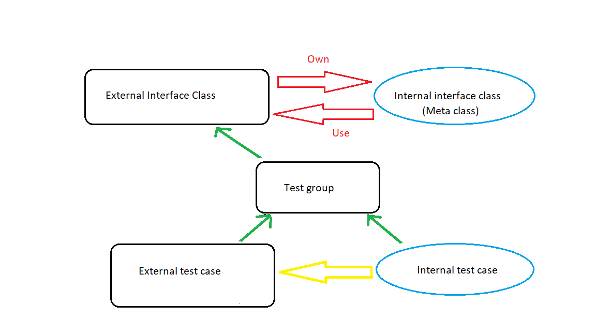
Solution: - Use meta class

Refer the next pages on how to enable this.

- Internal tests/interfaces folder structure:
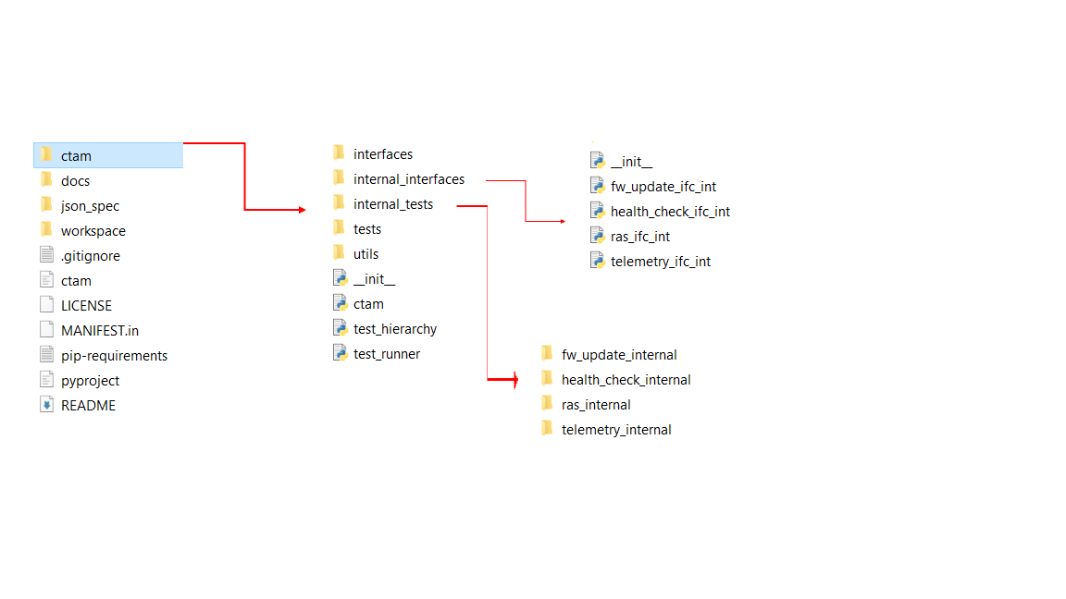

- Internal interface Meta Class creation:

- In the internal_interfaces folder, keep all the interface files which will contain functions related to internal test cases. Naming convention:
- File name (for eg.): telemetry_ifc_int.py
- Class name (for eg.): TelemetryIfcInt(type)

- Classes defined under internal interface files are Meta classes inheriting from 'type'.
- It will contain a function "__new__" with positional args: (cls, name, bases, data_dict) as shown below.
- The interface modules for the internal test cases will be defined under __new__ as shown in the below example.

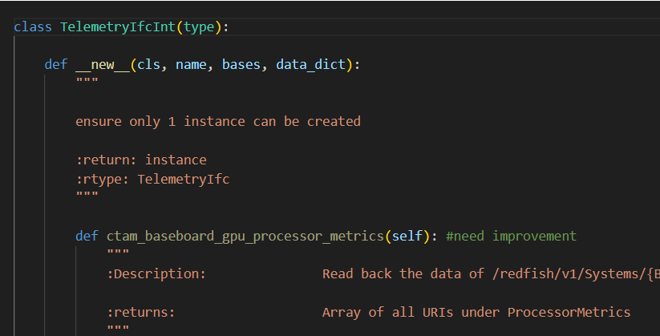

- Note (important) - All built-in modules used in the inner function need to be imported within the respective function scope also as shown in the below example

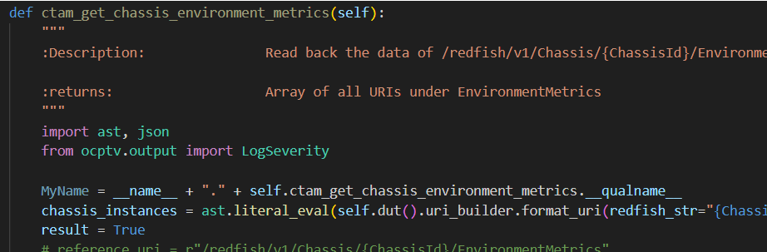
- After defining all inner functions, add the piece of code to the end of __new__ method of the (say, TelemetryIfcInt) class.

def get_function_object(f_def):
# compile the code containing the function definition
code_obj = compile(ast.Module(body=[f_def], type_ignores=[]), filename='<ast>', mode='exec')
# evaluate the code object and obtain the function object
namespace = {}
exec(code_obj, namespace)
return namespace[f_def.name]

# iterate and fill data_dict
src = inspect.getsource(TelemetryIfcInt)
node = ast.parse(src)
for func_def in ast.walk(node):
if type(func_def).__name__ == 'FunctionDef' and func_def.name !="__new__":
func_object = get_function_object(func_def)
data_dict[func_def.name] = func_object

# Create the class using the super() method
new_class = super().__new__(cls, name, bases, data_dict)

return new_class

- This code will dynamically allocate all function objects against their function name in data_dict dictionary by compiling the whole class using Abstract Syntax Tree(ast) module.
- Get_function_object() method converts the obtained FunctionDef object after compiling, to a callable Function object.
- External Interface class modifications:

- In External interface Class definition add a parameter named "metaclass"

class TelemetryIfc(FunctionalIfc, metaclass=Meta):

- Add the import statement for internal ifc file with alias "Meta"

try:
from internal_interfaces.telemetry_ifc_int import TelemetryIfcInt as Meta
except:
from utils.ctam_utils import MetaNull as Meta

- MetaNull is an empty meta class which is imported when internal testing if turned off.

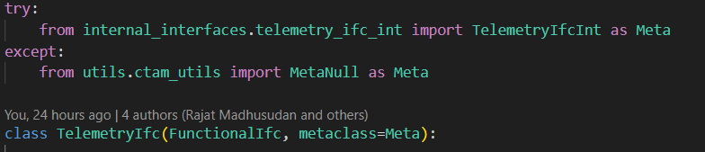

- Internal Test case execution:

- In test_runner.json, set internal_testing to true.
- Keep internal test cases in the internal test folder.
- Keep functions related to the internal test cases in the internal interface python file.
- Make sure interface files and classes follow the name convention mentioned at the start of the document.
- Set internal_testing to false if only external test cases need to be executed.

- Merging internal test case to external:

- When moving an internal test case to external, move the test case file to tests folder.
- Remove the function from internal interface file and keep it in the external interface file and remove the internal import statements, if any, within that function.

